**Attrition Vs Distance from Home**

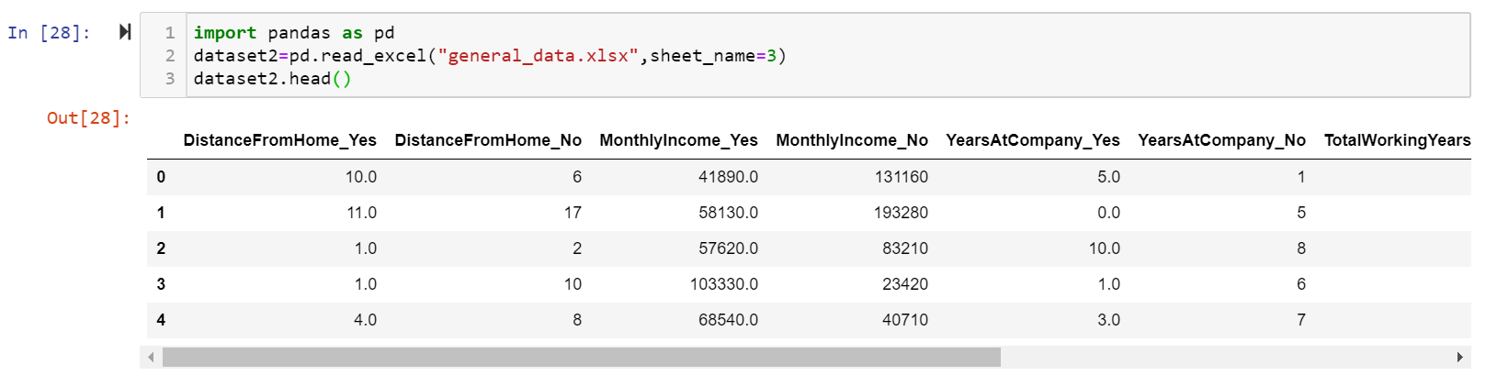

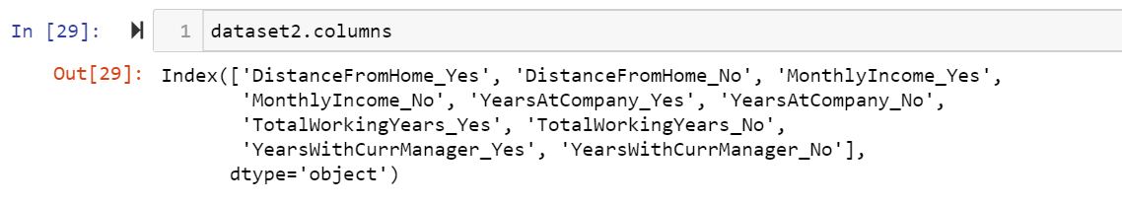

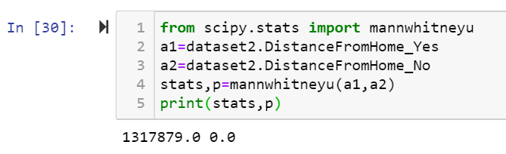

As the P value of 0.0 is < 0.05, the H0 is rejected and H1 is accepted.

H0: There is no significant differences in the Distance From Home between attrition (Y) and attirition (N)

H1: There is significant differences in the Distance From Home between attrition (Y) and attirition (N)

**Attrition Vs Income**

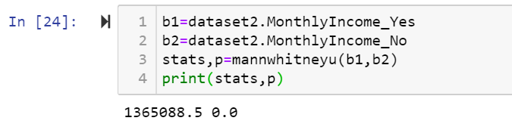

As the P value is again 0.0, which is < than 0.05, the H0 is rejected and h1 is accepted.

H0: There is no significant differences in the income between attrition (Y) and attirition (N)

Ha: There is significant differences in the income between attrition (Y) and attirition (N)

**Attrition Vs Total Working Years**

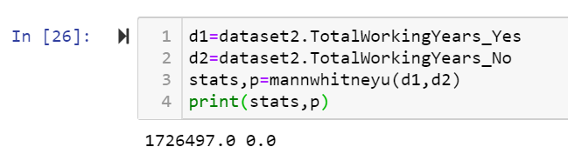

As the P value is again 0.0, which is < than 0.05, the H0 is rejected and h1 is accepted.

H0: There is no significant differences in the Total Working Years between attrition (Y) and attirition (N)

H1: There is significant differences in the Total Working Years between attrition (Y) and attirition (N)

**Attrition Vs Years at company**

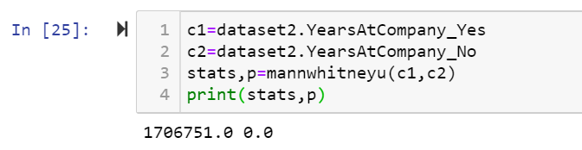

As the P value is again 0.0, which is < than 0.05, the H0 is rejected and h1 is accepted.

H0: There is no significant differences in the Years At Company between attrition (Y) and attirition (N)

H1: There is significant differences in the Years At Company between attrition (Y) and attirition (N)

**Attrition Vs YearsWithCurrentManager**

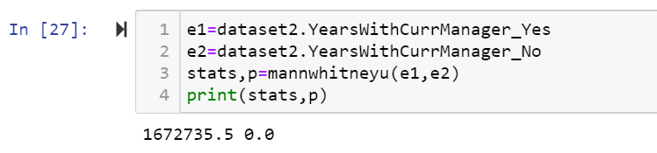

As the P value is again 0.0, which is < than 0.05, the H0 is rejected and ha is accepted.

H0: There is no significant differences in the Years With Current Manager between attrition (Y) and

attirition (N)

Ha: There is significant differences in the Years With Current Manager between attrition (Y) and

attirition (N)